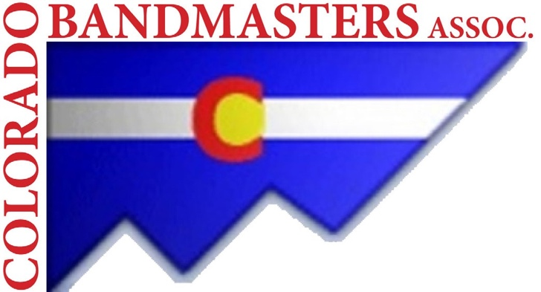
Colorado Bandmasters Association

2026 Convention Registration and 2026-2027 CBA Dues, if Paying by Check; Otherwise pay by credit card (preferred payment method) at www.coloradobandmasters.org

(An annual membership runs from the first day of the summer
convention to the day before the next summer convention)
Convention: July 16 and 17, 2026

Lakewood High School
9700 W. 8th Ave, Lakewood, CO 80215
Please print and use a different form for each person registering (Complete only if paying by Check)

CBA Region CBA Classification
Metro
1A (up to 400)
Southern
2A (401-850)
Northern
3A (851-1200)
Western
4A (1201-1650)

5A (1651+)
My primary assignment is in a(n)
Elementary School
Middle School MULTI
High School
College/University

Last Name: _________________________________
First Name: ___________________________________________

School/Business (or retired): __________________________________________________

School Address: ____________________________________________________________

School City:_____________________________ State:____Zip: _____________________

School Phone: ____________________________________________________________
Central Mtn.
Preferred Email: ____________________________________________________________

Home Mailing Address: __________________________________________________
Home City: ______________________State: _________________Zip: _______________
Home Phone:

MEALS
Breakfast and Lunch are provided for all convention attendees at no extra charge.
The THURSDAY evening banquet is included in your convention fee. Spouses, family members and guests are invited to attend for a fee of $65 per person. The banquet will be held at Baldoria on the Water (146 Van Gordon St, Lakewood).
Will you be attending? _____ If Yes, How Many? ________ Buffet (w/Vegetarian and GF Options); Banquet includes: Appetizers, Dinner and Dessert.

DUES AND CONVENTION FEES
Membership Dues (must be paid to attend the convention)
CBA REGULAR MEMBER DUES $70.00 ____________
CBA LIFETIME MEMBER DUES $530.00 ____________
CBA STUDENT MEMBER DUES $5.00 _____________
CBA Life and Retired Membership Dues $0.00 ____________
Convention Fees
Convention Registration (postmarked by 7/12/26) $110.00 _________ (includes breakfasts, lunches and banquet)
Convention Registration (paid after 7/13/26) $135.00 _________ (includes breakfasts, lunches and banquet)
University Students not attending the banquet $15.00________(includes breakfasts and lunches)
Students/First Year Teachers (in fall of 2026)/Hall of Fame/Retired Directors ATTENDING the banquet $85.00__________ (includes breakfasts, lunches and banquet)
Retired Directors/Hall of Fame Participants NOT attending the banquet $45.00 __________ (includes breakfasts and lunches)
ADDITIONAL Banquet meals $65 x = $_________ (for guests or family members)
Make checks payable to CBA: Check # TOTAL $ ___________

Dues and convention fees are PREFERRED to be paid by credit card.

Remember:

Deadline of

July 12, 2026 for reduced rate.
Don’t delay!!

Visit coloradobandmasters.org, or Mail To:

Colorado Bandmasters Association

Dr. Ed Cannava, Executive Secretary

6388 S. Dexter St.

Centennial, CO 80121-3266

